**Final Project - JAT-WD-E-B2**

**Adactin Hotel**

**1.) Booking Page**

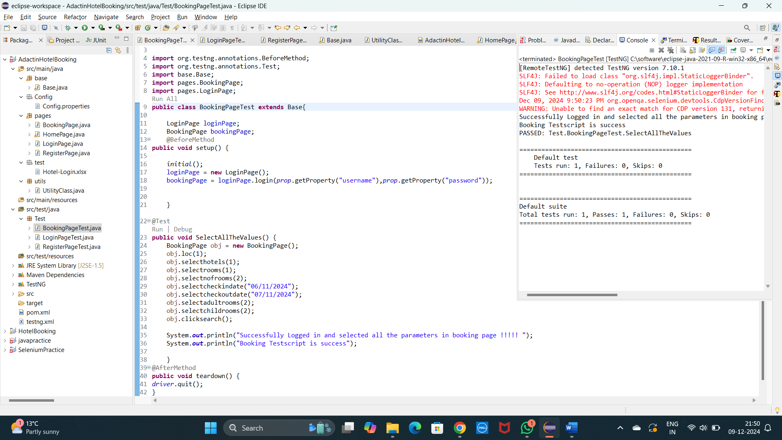

**2.) Login Page**

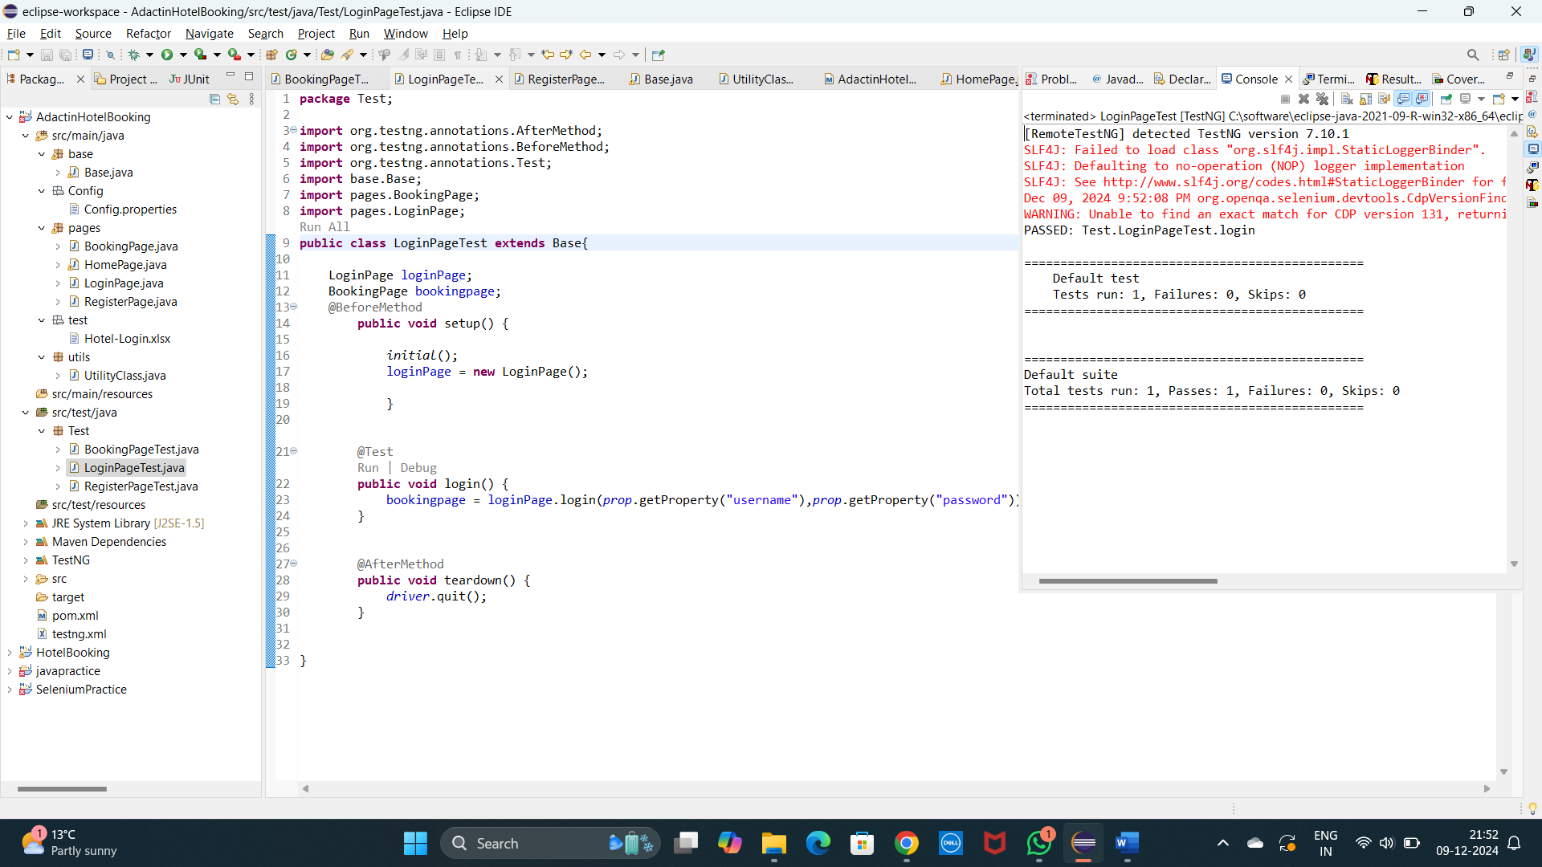

**3.) Register Page**

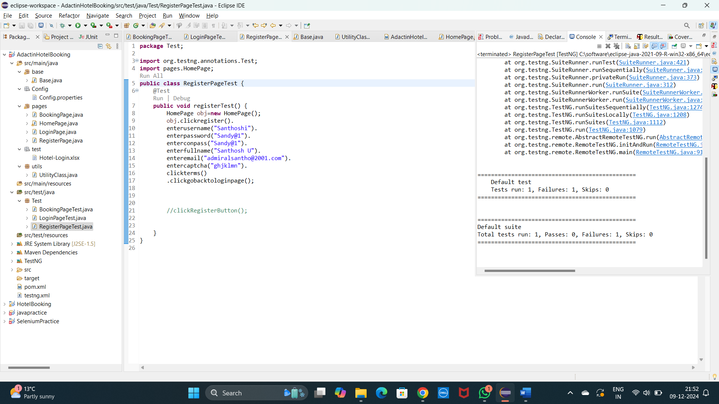

**For Register Page User should enter the Captcha Manually to avoid Failure test cases**

**Thank You,**

**Santhosh U**